**Brooklyn torah gazette**

**For parshas acharei mos 5782**

Volume 6, Issue 31 (Whole Number 286) 29 Nissan/ April 30, 2022

**The Jews of India:**

**A Tale of Three Cities**

**By**[**Rabbi Mordechai Becher**](https://aish.com/authors/48867722?aut_id=6669)

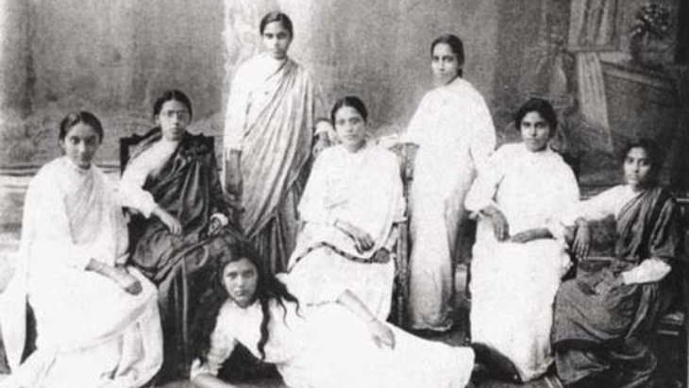

***Jews have been in India for over 2,000 years.***

Travel often challenges our pre-conceived notions and visiting India does that in a major way. Where else would a favorite Sabbath dish be a chicken-coconut curry?1 And where would you find a Jewtown Road with swastikas decorating some of the buildings?2 Only in India.

**The Bene Israel**

The history of the Jewish community in India, according to legends of the Bnei Israel of Bombay, dates to the time of King Solomon. We cannot confirm that date, but it does seem that the history of that community goes back over a thousand years. The Bene Israel Jews have a founding legend/narrative that they say dates to the time of the Second Temple. A ship set sail from Israel in about 175 BCE and sunk of the Konkan Coast, leaving seven couples as survivors of the shipwreck. The Bene Israel Jews, according to this legend, are descendants of those original couples.

*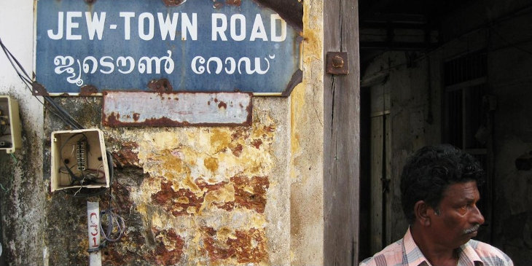****Street sign in Cochin***

They maintained the observance of Shabbat and kosher laws and tended to marry within the community.3 Their first encounter with other Jews was with the arrival of Baghdadi Jews from Iraq in the 19th century who brought them Jewish books and taught them Hebrew. One of India’s greatest military heroes was Lieutenant General J.F.R. Jacob, a Baghdadi Jew, who was responsible for military success against Pakistan and for helping to create the country of Bangladesh. He was also governor of the states of Punjab and Goa,4 and is buried in the Jewish cemetery in New Delhi.

**Baghdadi Jews**

The Iraqi Jews started moving to India in the 19th century and became successful merchants and business owners, primarily in Calcutta, but also in Bombay. There is a fountain in Bombay named after Flora Sasson, a Sassoon Library and the Sassoon docks; testimony to the prominence of just one Iraqi family in India. The Iraqi Jews maintained their ties with Baghdad and regularly sent questions to Iraq’s greatest Rabbinical authority, Rabbi Yosef Chaim of Baghdad, whose responses are recorded in his collection of responsa.5

Today one of Kolkata’s most popular bakeries is the Nahoum Bakery, founded in 1902 by Iraqi Jews and still owned by a descendant, Isaac Nahoum. This iconic bakery is owned by a Jew, employs Muslim bakers, produces famous Christmas cakes and most of its customers are Hindu.6 The Baghdadis established a Hebrew printing press in Calcutta,7 built beautiful synagogues, created and ran Jewish schools and even bore India’s greatest silent-screen actress, Ruby Myers, known by her stage name, Sulochana.8

*****Nahoum’s Bakery in Kolkata***

**Jewish Communities of Kerala**

One of India’s most beautiful states is Kerala, situated on the south-western coast, home to extensive spice and fruit plantations and to a solar-powered airport. Kerala was home to Jewish communities for at least 700 years. There is a magnificent synagogue in Crangamore which was built about 1345, and the Paradesi Synagogue, situated in Matanchery, which was built in 1568, and possesses a gold crown for its Torah scroll that was donated by the Maharaja of Travancore in 1808.

The Kerala Jewish community consisted of the Cochin Jews, known as the Malabar Jews, who claim to have been in India since the time of King Solomon, although more than likely originated in Persia in the 5th to 6th centuries.

The second community was the Paradesi Jews who came to India from Spain and Portugal in the 15th and 16th centuries following the expulsions from Spain in 1492 and Portugal in 1497.9

*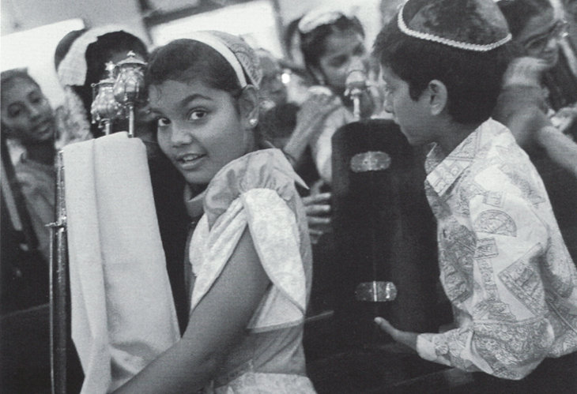****Simchat Torah in a Bombay synagogue, 1992***

The third component were Jews who immigrated from Arab countries such as Yemen and Iran and also from Europe, during the 18th and 19th centuries. The city of Cochin has an area know as Jewtown, where the synagogue is located, and where one can see swastikas, an ancient Indian decoration, carved on buildings in Jewtown Road.10

Deep in the heart of a Hindu neighborhood in Cochin one can find the grave of the kabbalist, poet and scholar, Rabbi Nechemia Motta who passed away in 1621. The grave is considered a holy site of prayer by the local Hindus, and still has a clear Hebrew inscription on the grave.

“*Here rest the remains of* *the famous kabbalist,*

*The influence of the light of whose learning shines throughout the country,*

*The perfect sage, the hasid, and* *G-d-fearing Nehemia, the son of*  
t*he dear rabbi and sage Abraham Mota.* *Our Master departed this life on*  
*Sunday, the 25th of Kislev, 5381.*

*May his soul rest in peace.”*

*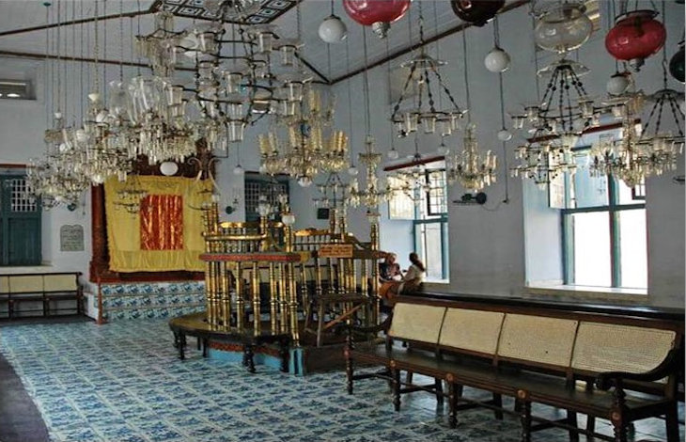****The Paradesi Synagogue in Kerala***

Most Indian Jews immigrated to Israel once the state was established in 1948, not out of fear, or due to antisemitism, for persecution and prejudice was not experienced by the Jews of India. They immigrated out of a conviction that Israel was their ultimate homeland and point of origin.

Today there are still about 18 synagogues in India, remarkably well preserved, although mostly not in use, and the Indian Jewish population numbers about 5000. There are currently about 70,000 Indian Jews in Israel, many of whom still preserve the unique customs and culture of their communities.11

The Last Jews of Kerala: The 2000 Year History of India’s Forgotten Jewish Community – Edna Fernandes (Skyhorse Publishing, NY: 2008)

The Jews of India: A Story of Three Communities (Israel Museum, Jerusalem: 2002)

An Odyssey in War and Peace: An Autobiography Lt Gen. J.F.R. Jacob

Responsa Rav Pe’alim

Jerusalem Post, article by Christabel Lobo/ JTA, Published**:**December 25, 2020

**

***Magen David Synagogue, Bombay***

India’s Jewish Heritage – Ritual, Art & Lifecycle – Editor, Shalva Weil (Mang Publications, Mumbai: 2004)

The Jews of India – Dalia Ray (Renaissance, Kolkata: 2016)

The Last Jews of Kerala: The 2000 Year History of India’s Forgotten Jewish Community – Edna Fernandes (Skyhorse Publishing, NY: 2008)

The Jews of India: A Story of Three Communities (Israel Museum, Jerusalem: 2002)

<https://anumuseum.org.il/>

*Reprinted from the Parshat Acharei Mos 5782 website of aish.com*



**Insights on Parshat**

**Achrei Mos**

The death of the two sons of Aaron remain one of the great mysteries that the Torah presents to us. The Talmud and Midrash have advanced several ideas as to why such a tragedy occurred and it may seem to a certain extent it was self-inflicted. The reasons for their failures are listed - they had drunk too much wine, they never intended to marry and father a family and they wanted their elders to pass on so that they could be the leaders of the people. Over the centuries other ideas of their failings have been enumerated by the commentators.

In the face of all of this we have the record of the Torah itself that their father Aaron was silent. The silence many times is the only acceptable answer in the face of tragedy. The silence indicates the line between the judgment of heaven and the understanding of life that humans bring to it. My thoughts are not your thoughts and my ways are not your ways, that is what the Lord says, and man must adjust to that difficult reality.

So, Aaron is silent. He does not complain, and he does not cast blame. Is he aware of the behavior of his sons? The Torah does not comment upon that either. Many times, parents really do not comprehend their children nor are they privy to their ambitions or thoughts. But the Torah leaves all of this as an open question as far as Aaron and his sons are concerned. We have no idea as to what he thought of his sons, but we can understand the anguish and pain that he must have suffered on that terrible day of tragedy. Aaron remains a symbol therefore of the ability to continue life even when life has struck a deadly blow to the person. In this respect I always felt that he is a prototype of Iyov who also seems to suffer for causes that are unknown and inexplicable. However, Iyov complains loudly and demands to know why. Aaron is silent and does not raise his voice either in anger or in doubt.

I can only imagine that the surviving sons of Aaron, Elazar and Itamar, are placed under enormous personal and emotional pressure. The older sons, Nadav and Avihu, were seen as the heads of the family and as the ones who bore responsibility for preserving the line of the priesthood and the holiness of the Tabernacle and Temple. Now they have suddenly been removed from the scene. Elazar and Itamar are the only ones left. Many times in human history we have seen that younger brothers who never expected to become a monarch or have a position of importance and influence, when fate decreed otherwise and made that younger person the head of the family or the leader of the country, rose to the occasion.

It is not that they imitated their older siblings who no longer were present, but rather it was that they were able to assert their own personality and their own inner greatness. One never knows the capabilities and potential that one has until and unless one is challenged by fate and life itself. Potential exists within everyone. The ability to bring forth that potential and to further it and strengthen it and make it beneficial, that is a challenge.

So, included in the tragedy of the deaths of the two older sons of Aaron is the response of the two younger sons who apparently rise to the occasion. Elazar will be the high priest that leads the Jewish people to  the land of Israel and Itamar will be the one that is able to organize and correctly finance the building of the tabernacle in the desert and other projects as well. The line of the priesthood of Israel that exists until today runs through Elazar and Itamar who never expected to be the ones that would have to bear that burden and meet that challenge. That is also part of the idea of Aaron's silence. For who knows how people will respond and who knows what potential will be released that will help build the Jewish people and humankind.

*Reprinted from the Parshat Acharei Mos website of Rabbiwein.com*

**Parshas Acharei Mos/Kedoshim:**

**Systems of Human Perfection**

**By Rabbi Bentzion Shafier**

**Founder of TheSmuz.com**

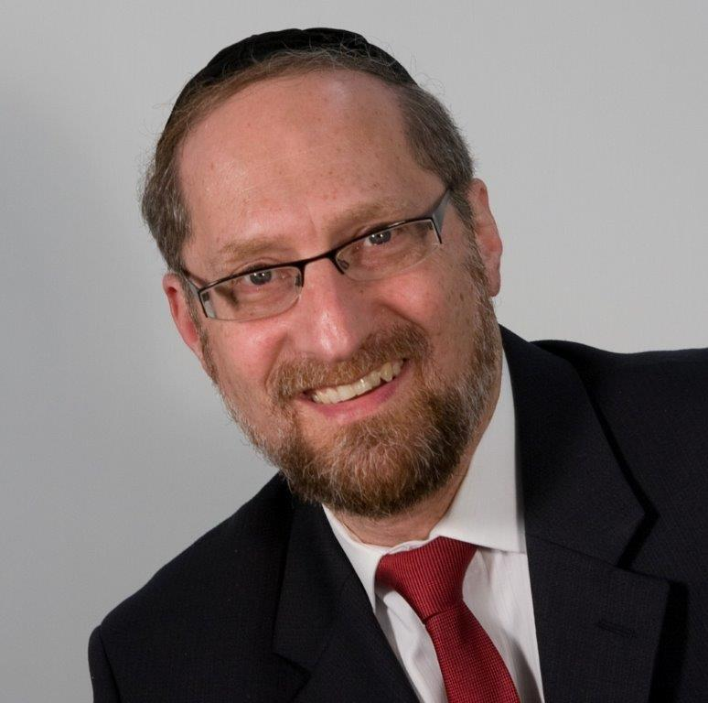

The Torah warns us many times and with many different exhortations not to consume blood. The Kli Yakar points out than in Devarim the Torah tells us not to eat blood because “It will be good for you and your children after you”. He explains that: “Consuming blood brings cruelty into the one who eats it, and the nature of the father is given over to his children to be like him. Therefore, the Torah warns us not to consume blood so that we don’t acquire this nature.”

It seems clear from the Kli Yakar that consuming blood will cause a change in the nature of the person who consumes it. His sensitivities and reactions will have changed, and he will become a different person. However, not only will he become callous and pitiless, these traits will become part of his genetic transmission, so that any child that he then has will have this same predisposition towards cruelty.

This concept seems difficult to understand. Firstly, how does consuming blood make a person cruel? Secondly, how does that change affect the very hereditary transmission of a person so that his children will be pitiless as well?

To understand the answer to this, we need to focus on the basic make-up of man.

The Chovos Ha’Levovos (Sha’ar Avodas Elokim 3) explains that HASHEM created man out of two very distinct parts – a nefesh ha’Schili (intellectual soul) and a nefesh Ha’Bahami (animal soul). The “I” that thinks, feels, and remembers is comprised of two separate and competing parts, each one with its own nature, tendencies, and needs. The nefesh ha’Schili desires only that which is good, right, and noble. It yearns to help others, it hungers for meaning and purpose, and more than anything, it needs to be close to HASHEM.

Then there is the other part of man — the animal soul. It too has desires and inclinations, and it too hungers for things. One way to better understand the animal soul in man is to visit its parallel in the wild kingdom.

**Understanding the Nefesh Ha’Bahami**

HASHEM imprinted into the essence of each animal all the instincts necessary for its survival as well as for the continuation of its species. The animal doesn’t have a cognitive, reasoning element. It doesn’t have an “I” that is the master of the ship. But it does have a vibrant essence that is programmed to seek out its needs. That part is the nefesh of the animal.

That nefesh is pure instinct, drives, and passions, and is affected by both internal and external triggers. In the spring, birds fly north and engage in a fury of nest-building and mating. The individual bird doesn’t purposefully choose its mate. Two robins don’t sit down and say to each other, “It’s time for us to settle down and raise a family.” The animal is attracted by the sight, smell, and sound of one of its species, and then will hotly pursue it – often becoming bonded for life. It is driven by instinct in a preset pattern.

Those instincts and desires are affected by various forces. A bird from a different species will not elicit the mating response, nor will even the same bird in a different time of the year. In the dead of winter, these desires lay dormant. The change in season brings them forward to the extent that they take over the existence of that bird. They have been pre-programmed to respond to stimuli that allow for the success of the individual bird and the species as a whole.

**The Answer to the Kli Yakar**

This seems to be the answer to the question. The Kli Yakir is teaching us that when the Torah forbids us to eat blood, it is because consuming it would make a dramatic change in our inner essence. We would be ingesting part of the nefesh of that animal, and it would become part of our own Nefesh Ha’Bahami. Our conscious reality would change because part of who we are is the animal soul, and we would thereby acquire cruelty. This change is so potent that if the person who drank that blood were to then have a child, that child would also have cruelty as part of his inner make-up.

Much like certain chemicals can affect a man’s mood; the Torah is teaching us that there are some properties that have a permanent effect on the nature of man. They change his Nefesh, and that changes the way that he thinks and feels.

Similarly, the mefarshim explain to us that none of the kosher animals are predators. The nature of a predatory animal is to hunt down and kill. If a person were to consume meat from such an animal, some part of the Nefesh of that animal would enter into man’s soul and he would acquire an aggressive, violent nature. The Torah forbids it because it would damage the fine balance in man.

This concept is very significant as it helps us better understand the Torah as the system of human perfection. HASHEM is the Creator, and He wrote the Torah as the guidebook for human growth. Contained within it are all the tools necessary to reach greatness. Some of the tools are easily understood and some takes years to fully comprehend, but the system is there. By following the guidelines, restrictions, and commandments, a person guarantees that he is headed in the right path – using his stay on the planet to grow and perfect himself.

*Reprinted from the website of theshmuz.com.*

**Hero of the Lodz Plague**

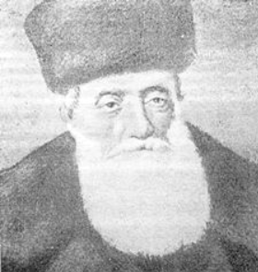

The city of Lodz, located about 85 miles southwest of Warsaw, contained the second largest Jewish community in prewar Poland, after Warsaw. At the turn of the twentieth century, the Rav, R’ Eliyahu Chaim Meisels zt”l, was sought after for his sagacious wisdom, piety and righteousness, and he earned the respect and affection of both the Chassidishe and Litvish communities residing in the city, a feat nearly unmatched at the time.

**Prosperous and Assimilated Industrialists**

Lodz was a city dominated by a clique of prosperous, assimilated industrialists and merchants. In addition to overseeing the provision of basic religious needs, the Rav worked energetically to convince many of his community’s wealthiest assimilated members to join in organizing a series of institutions to serve the growing numbers of impoverished Jews drawn to economic opportunities in Lodz. Stories about R’ Elya Chaim credit him with preventing pogroms in Lodz and protecting Jewish interests in the city and beyond. One specific story stands out and was spoken of with awe and incredulity, among the citizens of Lodz. It is recorded in old Chevra Kadisha records from that time-period and it recounts the following incident.

In the late 1800’s, a calamitous plague - most likely Typhus - broke out in the city of Lodz, affecting its residents and the nearby environs. The plague swept across the area felling Jews and gentiles alike. Accounts from local newspapers from those days reported that the plague prowled among the citizens and villagers in a terrifying way and there was almost no house without someone ill.

Mortality was huge and carpenters around the city and nearby towns did nothing but build coffins. “People walk around apathetic because there was no way to prevent the plague,” wrote one Polish newspaper. Another delivered an even more dramatic account: “Funerals usually take place without crying, because often the whole family of the deceased lies in a fever and there is no one to cry over the coffin. It often happens that a mother lying unconscious in a fever does not know that her dead child is being taken away from the house.”

Often death came very quickly. “In the morning you are healthy, in the evening you are gone” one could hear constantly back then. R’ Elya Chaim remained healthy throughout the terrible days when the plague ravaged his community and he worked above and beyond to care for and assist all those in need.

**Demanding Even More Charity**

He called for public fasts and demanded even more charity from those who could afford it. He practically didn’t sleep as he was called from house to house to soothe his constituents and often say Viduy and recite Krias Shema with them before they passed away.

Finally, R’ Elya Chaim decided that enough is enough and he must be more proactive if he wished to remove this teribble catastrophe from among his midst. He Suddenly Appeared Wearing a White Kittel that he only wore on Yom Kippur and Pesach by the Seder, as well as his Talis and Tefillin.

As curious bystanders watched in awe, R’ Elya Chaim marched to the Lodz Jewish cemetery and halted as he reached the front gate. Then, in an ethereal voice that sounded almost other-worldly, he announced: “I will not allow the Malach Hamaves (angel of death) to take one more person from my city. Hear me now. It is either you or me! Either you go or I will go!”

**Walked Silently to the Cemetery**

With that, he walked silently into the cemetery and laid himself down inside the front gate. He took out a sefer Tehillim and began to daven with copious tears streaming down his cheeks that Hashem remove the plague from the city. He didn’t care if onlookers watched him with their jaws agape. He needed to stop the plague right now and he intended to make sure that happened.

Members of the Chevra Kadisha were called and they were the first ones to testify that their great and holy rabbi’s efforts bore fruit. R’ Elya Chaim insisted that he would not leave until the plague was gone and he did not have to wait long. Within a short while, the infections began to drop and soon nobody was becoming sick anymore. And those who were sick, started to get better and their symptoms faded, almost overnight. People in Lodz would comment with a mixture of love and devotion, that their holy Rabbi literally forced the angel of death to leave the city of Lodz. (Ish L’Rayahu Shemos 5763)

*Reprinted from the Parshat Acharei Mot parsha sheet of R’ Yedidye Hirtenfeld’s whY I Matter for the Young Israel of Midwood in Brooklyn.*

**Modern Day Examples**

**Of Kelot Hanefesh**

**From Nadav and Avihu**

**From the Talks of the Lubavitcher Rebbe**

**Rabbi Menachem Mendel Schneerson, Zt”l**

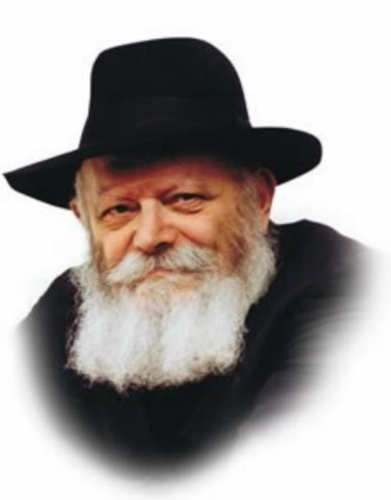

This week's Torah portion, Acharei, opens with the verse "G-d spoke to Moses after the death of the two sons of Aaron, when they came near before G-d and died."

The commentator Ohr HaChaim explains that Nadav and Avihu died because of an intense longing to be close to G-d. Their deaths occurred as a result of kelot hanefesh, that is, their souls were simply unable to remain in their physical bodies any longer.

Many Tzadikim of past generations also experienced a semblance of kelot hanefesh. The Chasidim of Poland used to tell the following story of the Rebbe of Modzhitz:

The Rebbe of Modzhitz possessed an incredible capacity for Chasidic melodies. Whenever he sang it was with great dveikut -- attachment to G-d.

Once, when he fell ill, his doctors advised that he undergo surgery, but they were reluctant to operate because his heart was weak and he might not be able to withstand the pain.

When the Rebbe heard their concerns, he suggested that he sing a Chasidic melody. His intense concentration would render him unaware of his physical surroundings. The doctors could then operate and he would feel nothing.

And so, it was. The Modzhitzer Rebbe sang a nigun, and the operation was performed successfully. The Rebbe was so absorbed in the melody and so attached to G-d that he had absolutely no perception of his physical body.

Another story is told about the Rebbe Rashab, the fifth Lubavitcher Rebbe, father of the Previous Rebbe:

Once, while staying in Vienna, the Previous Rebbe walked into his father's room and found him sitting on the sofa. The Rebbe Rashab's eyes were open, but it was obvious that he was oblivious to his surroundings. The Previous Rebbe left and returned an hour later, only to find his father still motionless. The Rebbe's state continued for hours, during which he seemed to be in another world.

When the Rebbe Rashab "awoke," he was not aware of what day it was, nor could he remember where they were.

Sometime later the Rebbe Rashab revealed that he had been meditating on a very deep Chasidic concept. The subject of his contemplation was later written about in a book.

The intensity of the Rebbe Rashab's deveikut had brought him to a state of detachment from the physical world. Even after his "return" he was unable to recall the date and where he was.

What happened to the Rebbe was similar to the kelot hanefesh of Nadav and Avihu, when their souls escaped the limitations of their bodies as a result of their deep attachment to G-d.

*Reprinted from the Parshat Achrei 5757/1997 edition of L’Chaim Weekly. Adapted from Likutei Sichot, vol. 27*